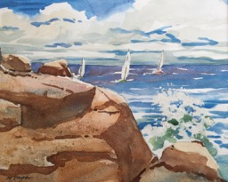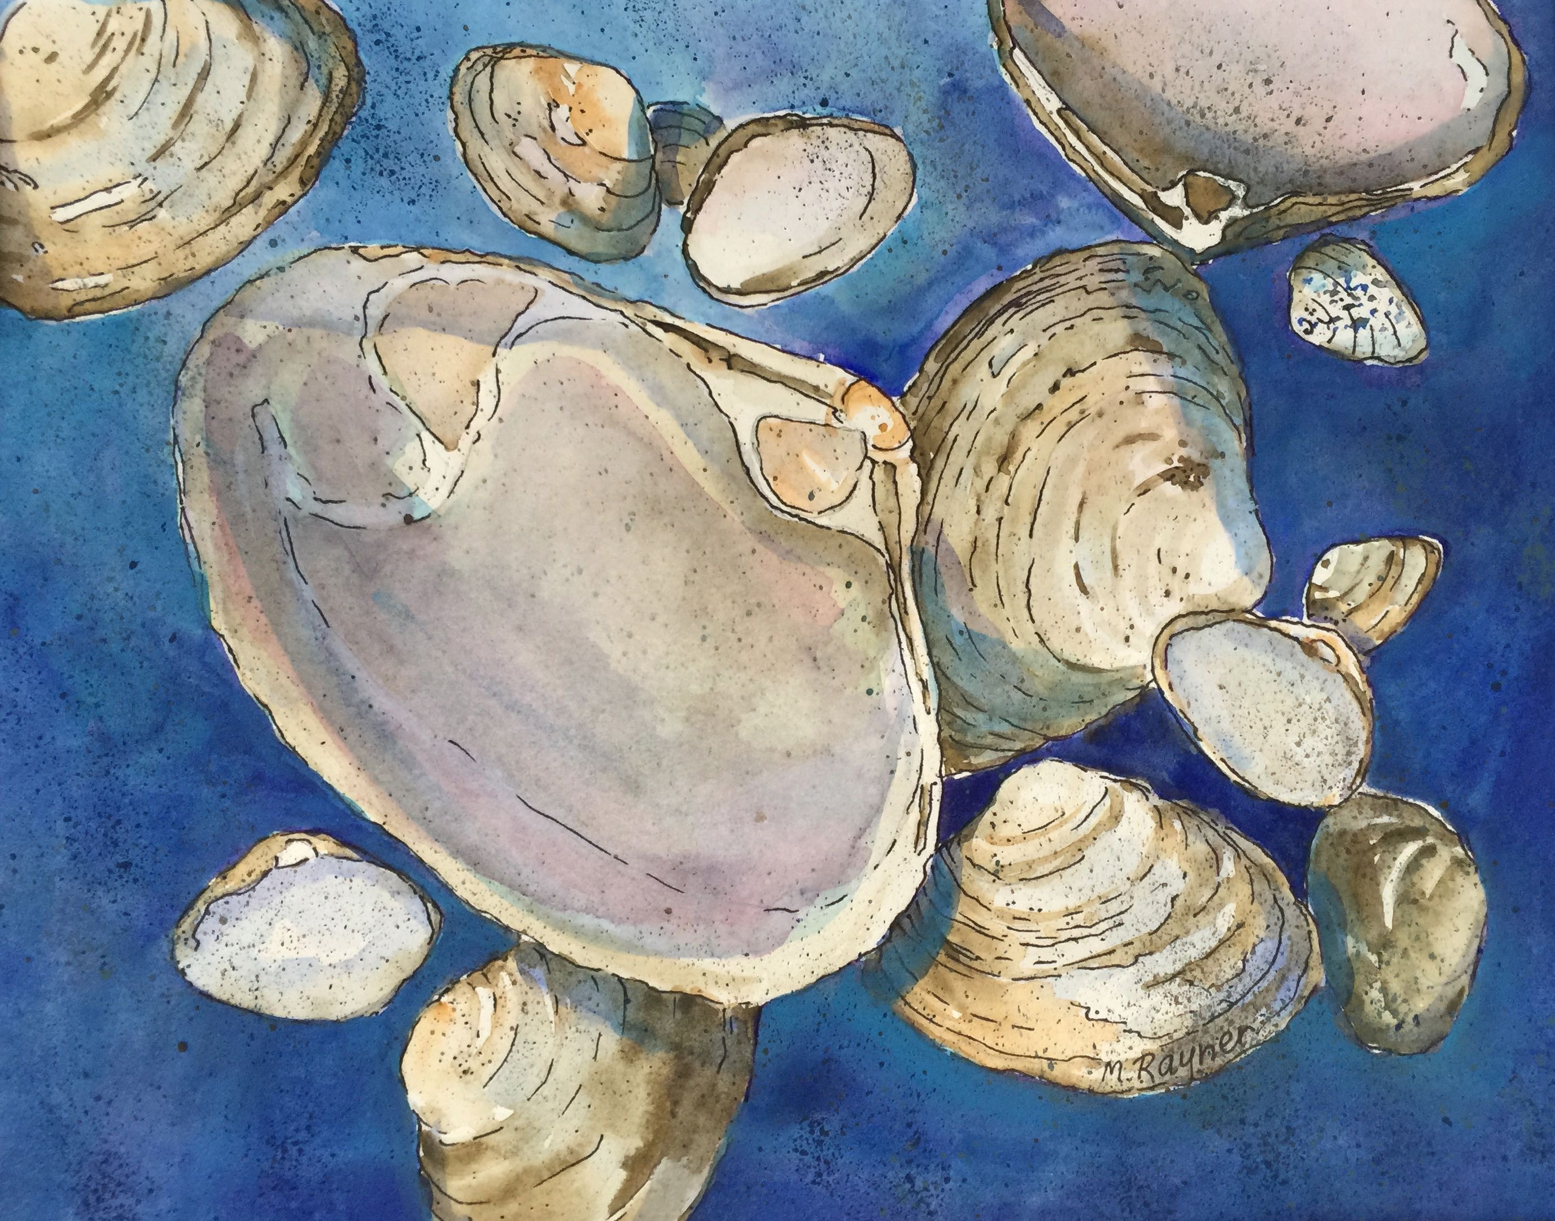

Watercolor Class with Marion Rayner

Marion will be conducting 6 watercolor classes on Tuesday afternoons, 1:00-3:00 pm, at the Manchester Community Center, beginner to intermediate. Classes will start Tuesday, September 20, 2022.

Each lesson will show you how to use simple watercolor techniques to get the results you are looking for in your painting. Some of the techniques include: wet-in-wet, scraping, dry brush, spattering, sponge, salt, etc. We will be painting a variety of subjects: landscapes, seascapes, shells, flowers, etc. Each week will feature a new painting.

Come join us! You will be surprised at how easy and rewarding watercolor painting can be.

