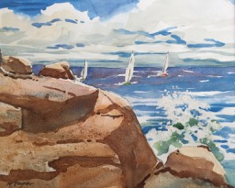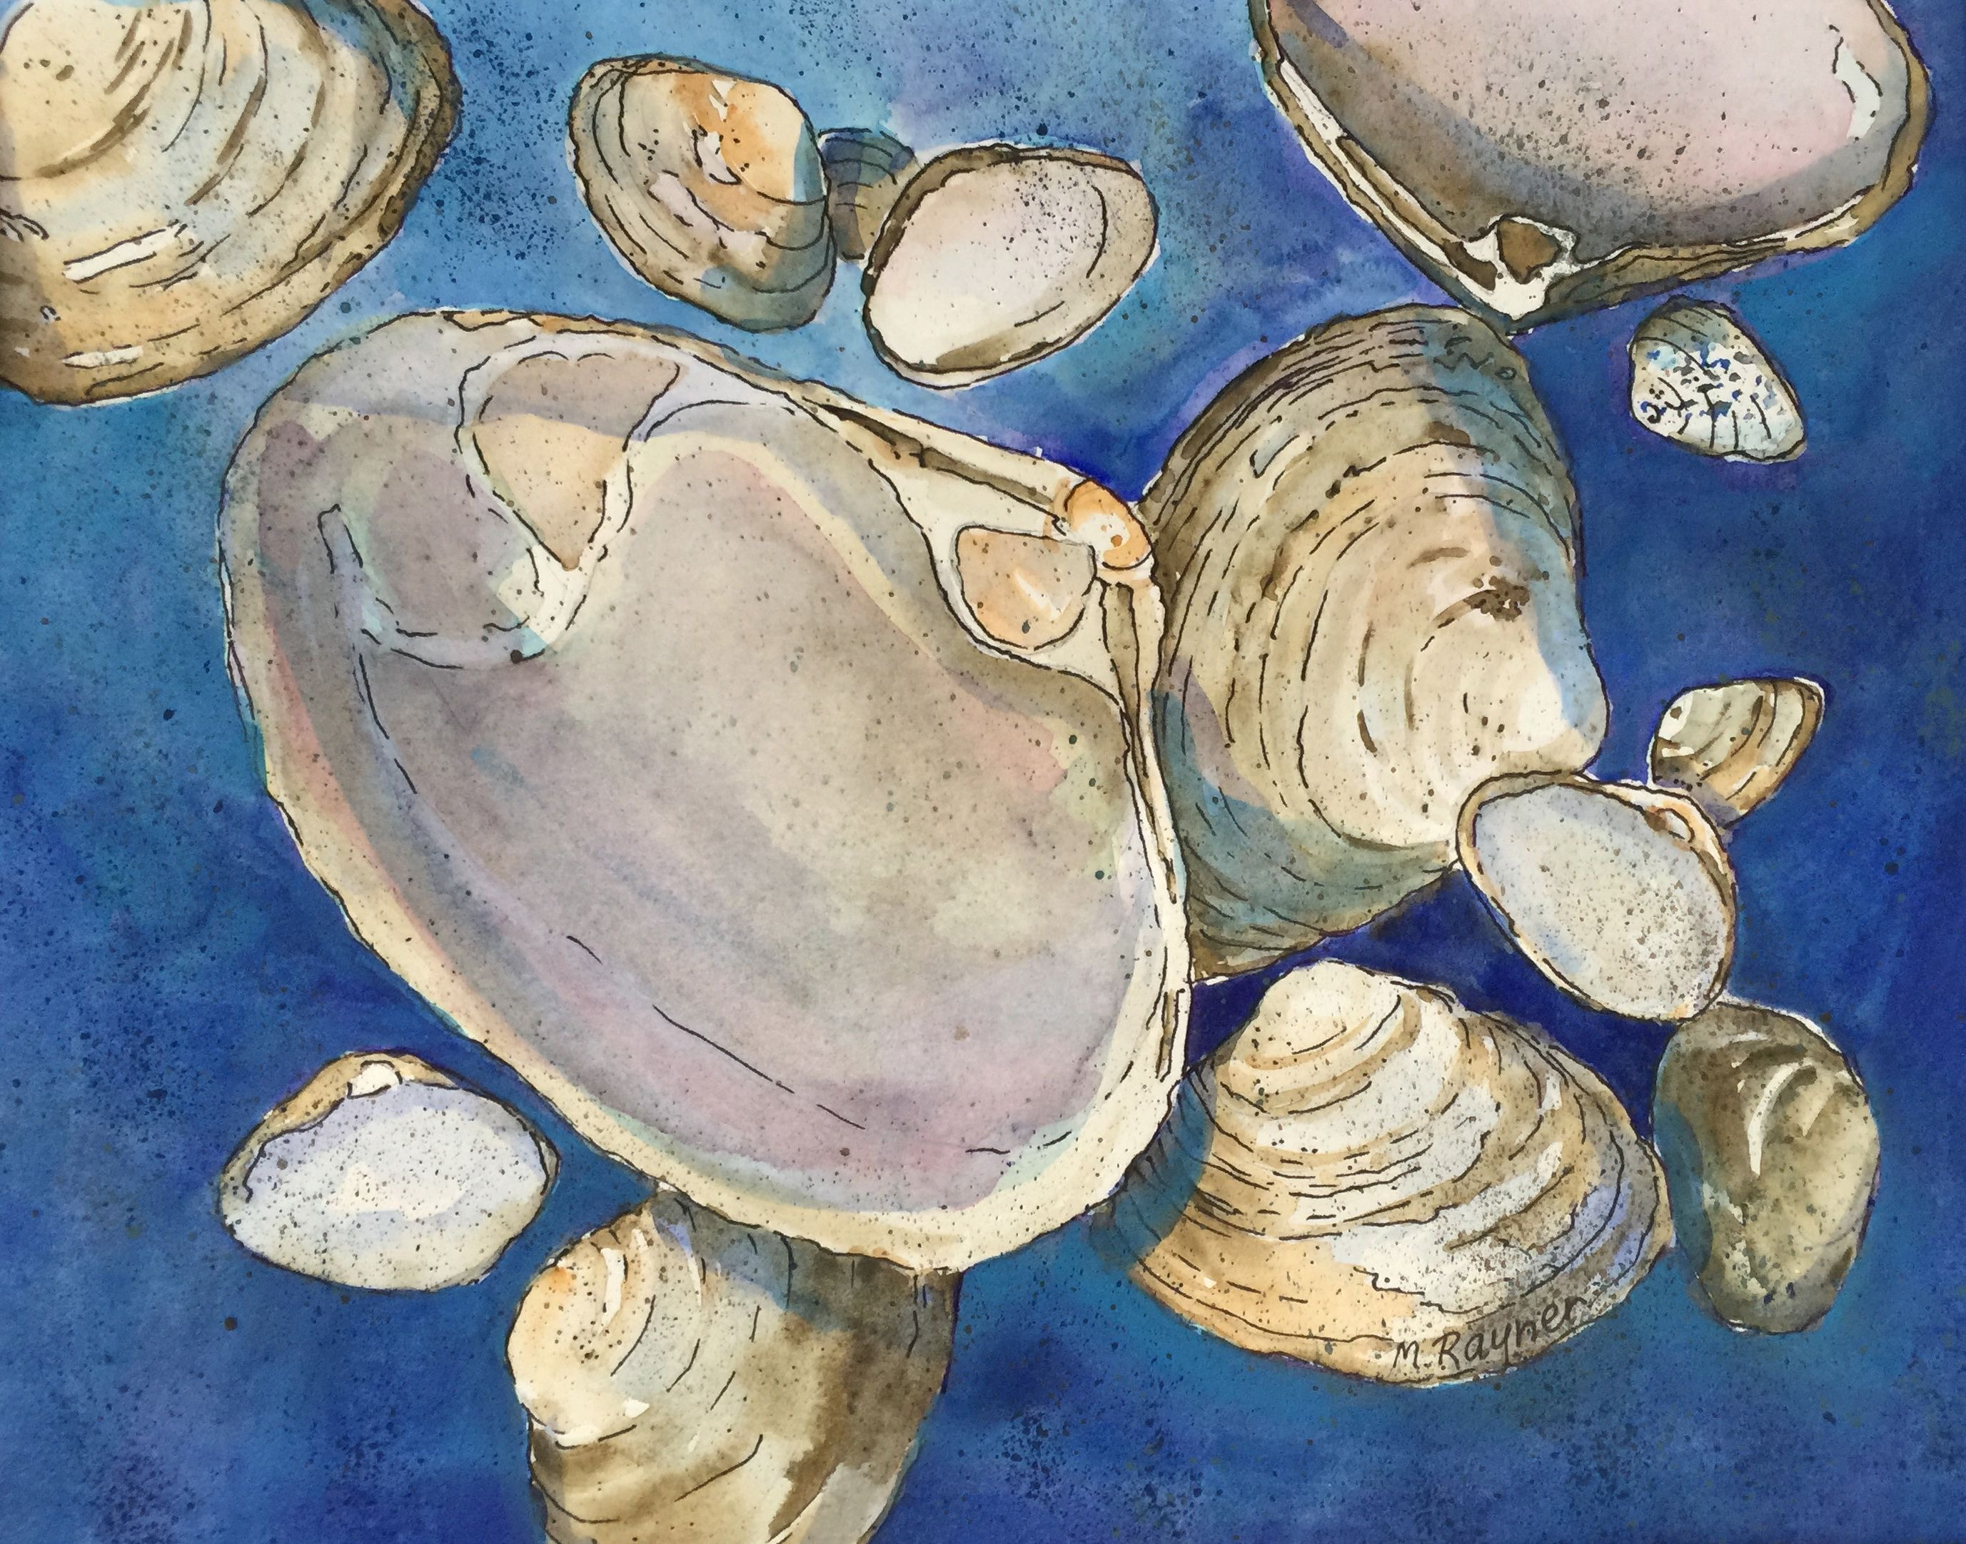

Watercolor Class with Marion Rayner

Marion will be conducting 6 watercolor classes on Mondays from 9:45 – 11:45 am, at the Manchester Community Center, beginner to intermediate. Classes will start on Monday, October 17th.

Each lesson will show you how to use simple watercolor techniques to get the results you are looking for in your painting. Some of the techniques include: wet-in-wet, scraping, dry brush, spattering, sponge, salt, etc. We will be painting a variety of subjects: landscapes, seascapes, shells, flowers, etc. Each week will feature a new painting.

The cost of the class is $125 for members and $150 for non-members.
Come join us! You will be surprised at how easy and rewarding watercolor painting can be. To sign up please call 978-526-7626 or email at the manchestercommunitycenter@gmail.com

